Introduction:
Starting in ALM 16, you can use the SA REST API to query data against the Web Administration Add-on. The existing REST API calls for ALM 15.5 Web Administration does not work for ALM 16. The examples provided here demonstrate how to use REST API to execute some of the most common administrative tasks in the Web Administration Add-on. Documentations on the Site Administration REST API is provided in the link below:
https://admhelp.microfocus.com/alm/api_refs/site_admin_rest/Content/SA_REST_API/Welcome.html

Table of Contents:
- Server Connection
- Activate or Deactivate Users
- Add Users to Projects
- Create Projects
- Create Users
- Delete Users
- Delete Users from Projects
- Unlock Users
- List Domains and Projects
- List Users in Projects

- Server Connection – Connect to your ALM instance to perform tasks using SaaS Administration REST API
- Bring up the QC_SaaSAdminAddon.xlsm
- Navigate to the Connection tab
- Enter the ALM Server URL
- Enter your API Key and Secret. If you don’t have this information then, you need to request from you Customer Admin to create one.
- Enter the Customer ID. You can get this information by logging into the Administration Addon -> SaaS Information -> Reports -> Parameters -> Customer ID report.
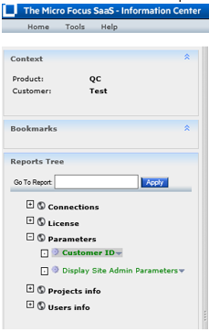

- Select the task you want to perform. Below are the possible Tasks
- Activate/Deactivate Users
- Add Users to Projects
- Create Projects
- Create Users
- Delete Users
- Delete Users from Projects
- Unlock Users
- List Domains and Projects
- List Users in Projects
- Click on “Connect” button to execute
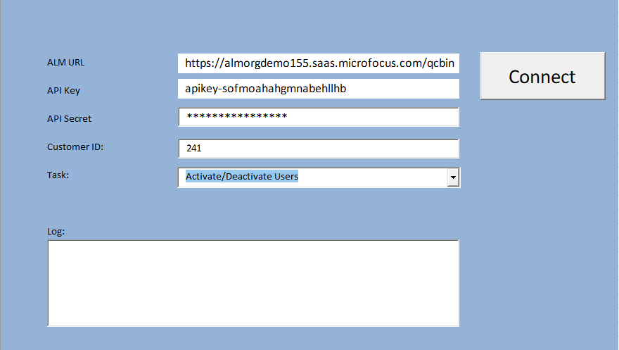
- Activate or Deactivate Users – Use REST API to Activate or Deactivate users.
- Navigate to the “Activate or Deactivate Users” tab
- Fill in the Excel row(s) with the user’s information to active/deactivate
login-name – Name of the user to apply task
is-activate – Set value to “true” to activate user and “false” to deactivate

Example:
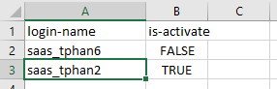

- Add Uses to Projects – Use REST API to a add users to projects and groups. This example can also be used to remove a user from a group in a project. A user will need to belong to at least 1 group. You cannot remove a user from all groups in a project.
- Navigate to the “Add Users to Projects” tab
- Fill in the Excel row(s) with the user’s information to add to project
domain – Name of domain
project - Name of project
user – Name of user to be added
role-name – Name of the group in the project

Example:
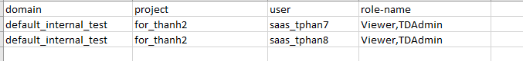

- Create Projects – Use REST API to add project to instance
- Navigate to the “Create Projects” tab
- Fill in the Excel row(s) with project’s information to create
Domain – Name of the domain to place the project in
name - Name of the project to be created
create-from-domain – Source project domain
create-from-project – Source project name
db-type – 1 for Oracle and 2 for MS SQL
db-server-name – Oracle host name
tablespace - tablespace where data will reside (required for Oracle)
temp-tablespace - temp tablespace (required for Oracle)
is-active – Project is active after creation
copy-options – Data to copy from source project (Please refer to online documentation for complete list of options)

Example:

- Create Users – Use REST API to create new users in instance
- Navigate to the “Create Users” tab
- Fill in the Excel row(s) with user’s information to create
email - Email of the user. Must be unique for SSO.
phone - Phone of the user
role – SaaS Add-on Role. Possible value are “Basic User” and “Customer Admin”. Other roles are possible if existing in instance.
login-name – Login Name of the user. Must be unique.
full-name – Full Name of the user.
idp-name – For SSO. Possible value is “alm” for SSO and “local” for non SSO users.
identity-key – For SSO. Must be unique value. Can be email or login name depending on setup. Field is case sensitive.
send-notification - Set value to “true” to send email to user with login info and “false” to not send email
is-active - Set value to “true” to make user active or “false” to deactivate user

Example:

- Delete Users – Use REST API to delete users from instance
- Navigate to the “Delete Users” tab
- Fill in the Excel row(s) with the project’s information to delete
login-name – Name of the user to delete from instance

Example:
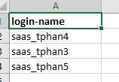

- Delete Users from Projects – Use REST API to delete users from projects
- Navigate to the “Delete Users From Projects” tab
- Fill in the Excel row(s) with the user’s information to delete
domain - Name of domain
project - Name of prjoect
user - Name of the user to delete from project

Example:
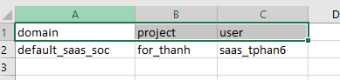

- Unlock Users – Use REST API to unlock users from Site Admin
- Navigate to the “Unlock Users” tab
- Fill in the Excel row(s) with the user login name
Example:
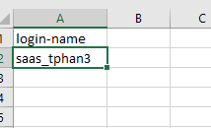
- List Projects and Domain – Use REST API to get list of domains and projects in the instance. Only the list of projects under the End Customer will be displayed.
- Navigate to the “List Domains and Projects” tab
Example:
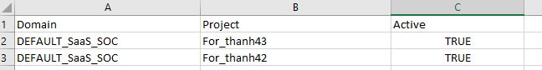

- List Users in Projects – Use REST API to get list of projects and the users in the project.

Example:
